**Project Design Phase-II**

**Technology Stack (Architecture & Stack)**

|  |  |
| --- | --- |
| Date | 05 July 2025 |
| Team ID | LTVIP2025TMID35592 |
| Project Name | EduTutor AI: Personalized Learning With Generative AI And LMS Integration |
| Maximum Marks | 4 Marks |

**Technical Architecture:**

The Deliverable shall include the architectural diagram as below and the **information as per the table1 & table 2**

**Example: Edututor Ai – Personalized Learning With Generative AI and LMS Integration**

**Reference:** [**https://www.educause.edu/initiatives/generative-ai**](https://www.educause.edu/initiatives/generative-ai)

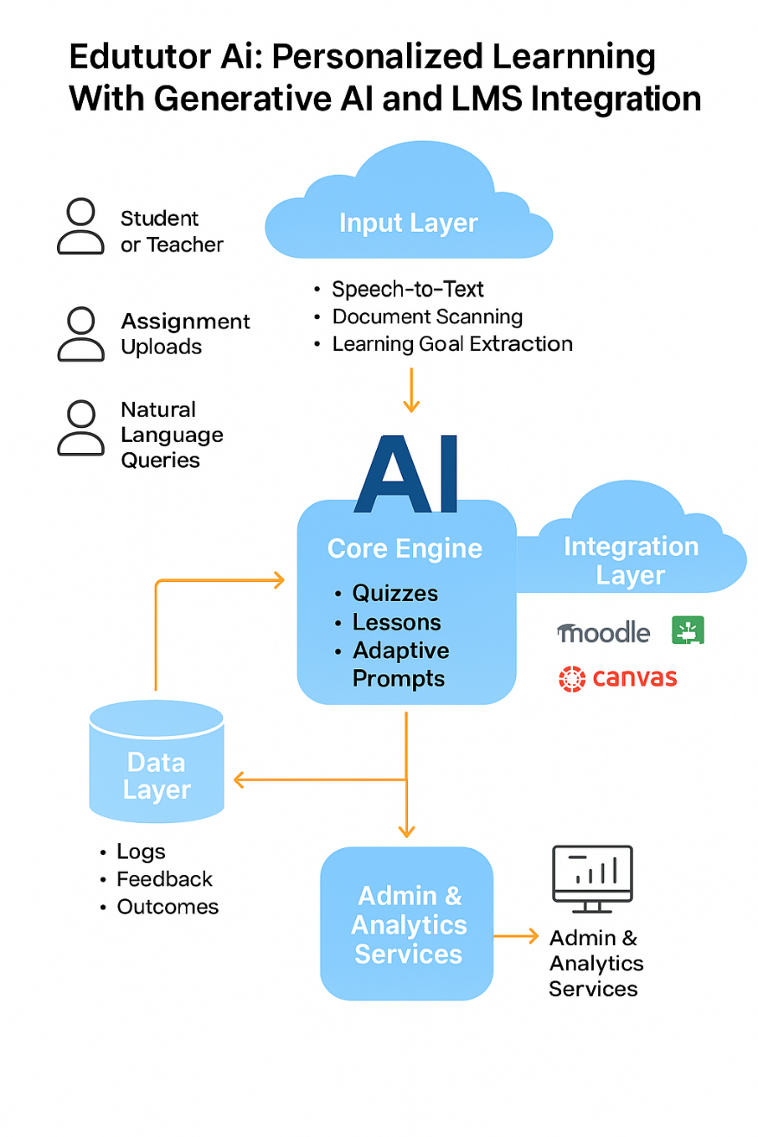

Guidelines:

Edututor AI intelligently personalizes learning using generative AI and real-time analytics.  
It captures inputs from students and teachers to generate lessons, quizzes, and feedback.  
Content is delivered via LMS platforms like Moodle or Canvas, enabling seamless engagement.  
Every interaction improves learning outcomes through continuous AI model refinement.

Let me know if you'd like this styled for a poster, pitch deck, or landing page!

**Table 1 – System Components Overview:**

|  |  |  |
| --- | --- | --- |
| **S.No** | **Component** | **Description** |
|  | Input Interface | Accepts prompts from instructors, student profiles, lesson files, and LMS data streams |
|  | AI Analysis Layer | Processes user data, identifies learning needs, and extracts instructional goals |
|  | Generative AI Engine | Produces adaptive lesson plans, quizzes, and feedback personalized to each learne |
|  | LMS Integration Module | Publishes AI content to platforms like Moodle, Canvas, and Google Classroom |
|  | Instructor Feedback Loop | Allows educators to review, refine, and personalize AI-generated content |
|  | Learning Analytics Core | Monitors performance, engagement, and outcomes for continuous learner and model improvemen |

**Table-2: Infrastructure & Delivery:**

| **S.No** | **Layer** | **Technology/Approach** |
| --- | --- | --- |
|  | Deployment | Cloud-native (AWS/Azure/GCP), on-premise, or hybrid |
|  | Scalability | Auto-scaling containers and microservices |
|  | Security | Role-based access control, data encryption, FERPA/GDPR compliance |
|  | API Layer | RESTful APIs for integration with external tools and LMS platforms |
|  | Monitoring & Logging | Centralized dashboards with real-time metrics, logs, and alerts for model and system monitoring |
|  | Continuous Improvement | Feedback-driven training, adaptive tuning using real-world performance data |

**References:**

1. **🔗** [**GitHub – EduTutor AI Project Repository**](https://github.com/kamakshiiswarya/EduTutor-AI-Personalized-Learning-with-Generative-AI-and-LMS-Integration)**.**
2. **🔗** [**EDUCAUSE – Generative AI in Higher Education**](https://www.educause.edu/initiatives/generative-ai)
3. **🔗** [**Instancy – The Future of Learning: Generative AI in LMS**](https://www.instancy.com/the-future-of-learning-generative-ai-in-lms/)
4. **🔗** [**Springer – Developing Generative AI Functionalities in a Social LMS**](https://link.springer.com/article/10.1007/s44163-024-00168-7)